Box2D:

Joints

Box2D
What's Box2D?
- Physics!!!
- A thin Java wrapper around the C++ engine
- References (RTFM):
  - https://box2d.org/manual.pdf
  - https://github.com/libgdx/libgdx/wiki/Box2d

Summary

- Initialization
Box2D.init()
- Creating a World
World world = new World(new Vector2(gx,gy), true);
- Debug Renderer
Box2DDebugRenderer render=new Box2DDebugRenderer();
- Stepping the simulation (in the render() loop)
  - https://gafferongames.com/post/fix_your_timestep/
private float accumulator = 0;

private void doPhysicsStep(float deltaTime) {
// max frame time to avoid spiral of death (on slow devices)
float frameTime = Math.min(deltaTime, 0.25f);
accumulator += frameTime;
while (accumulator >= TIME_STEP) {
WorldManager.world.step(TIME_STEP,VELOCITY_ITERATIONS, POSITION_ITERATIONS);
accumulator -= TIME_STEP;
}
}
- Rendering
debugRenderer.render(world, camera);
- Bodies:
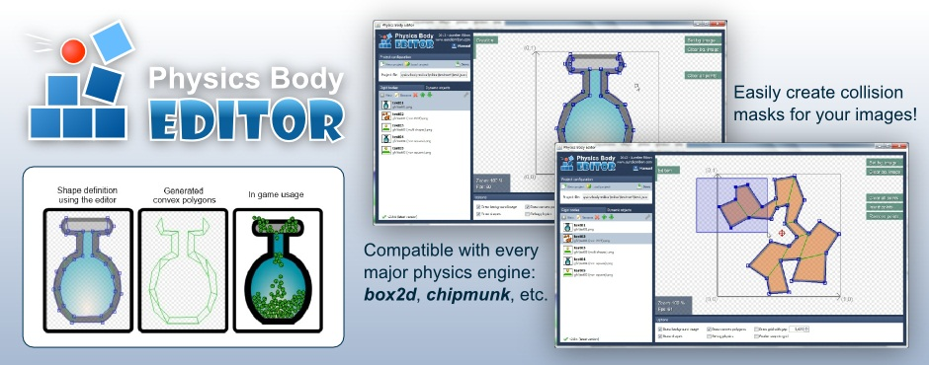
  - Static
  - Dinamic
  - Kinematic
- Impulses/Forces
- Fixture Shapes (box2d-editor)
- Sprites and Bodies (Box2D’s User Data)
- Sensors
- Contact Listeners
- http://www.iforce2d.net/b2dtut/
- Units

JOINTS:
What Is A Joint?
Types Of Joints In Box2D:
- Weld Joint
- Distance Joint
- Friction Joint
- Motor Joint
- Mouse Joint
- Prismatic Joint
- Pulley Joint
- Rope Joint
- Revolution Joint
- Wheel Joint
- Gear Joint

- Weld Joint
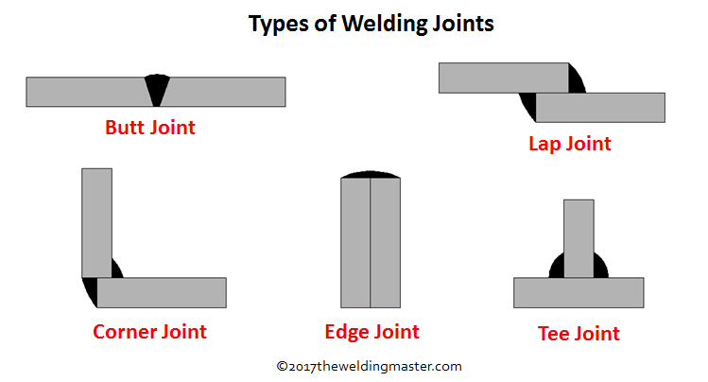

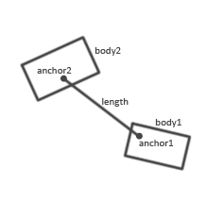
- Distance Joint
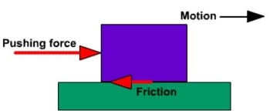
- Friction Joint
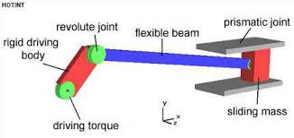
- Prismatic Joint, Revolute Joint & Gear Joint
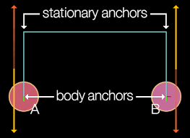
- Pulley Joint
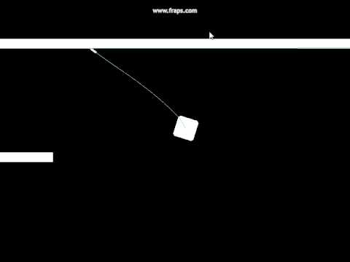
- Rope Joint
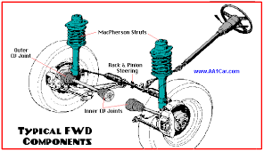
- Wheel Joint

Summary:

- Two bodys
- Different Anchors and constraints to do the joint definition
- world.createJoint(jointDefinition)
- Examples

Thanks To ALL

